Raising funds & awareness for regional nonprofits
GiveLocalNRV is a virtual fundraising platform offered all year to nonprofits serving the New River Valley. The signature event for this initiative is our annual giving day.
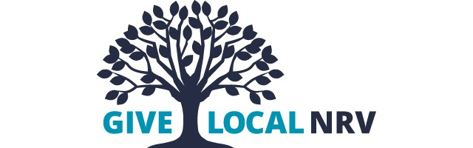
The GiveLocalNRV Giving Day harnesses the generosity of the New River Valley community by raising funds and awareness for nonprofits serving our region during the month of June. The online event culminates in a 24-hour period of giving with incentive grants and prizes funded by sponsors. Donors are encouraged to support their favorite organizations with a donation of $5 or more to help those organizations reach their goals.
Since 2014, the event has raised more than $4.3 million for local nonprofits. The CFNRV broadly promotes Giving Day and individual nonprofit organizations are responsible for promoting their work. Each year, early giving for the event kicks off on June 1, so nonprofits have the opportunity to fundraise in the weeks leading up to the Giving Day.
While the giving day is the signature event for this initiative, organizations use the givelocalnrv.org website year-round to fundraise for their missions.
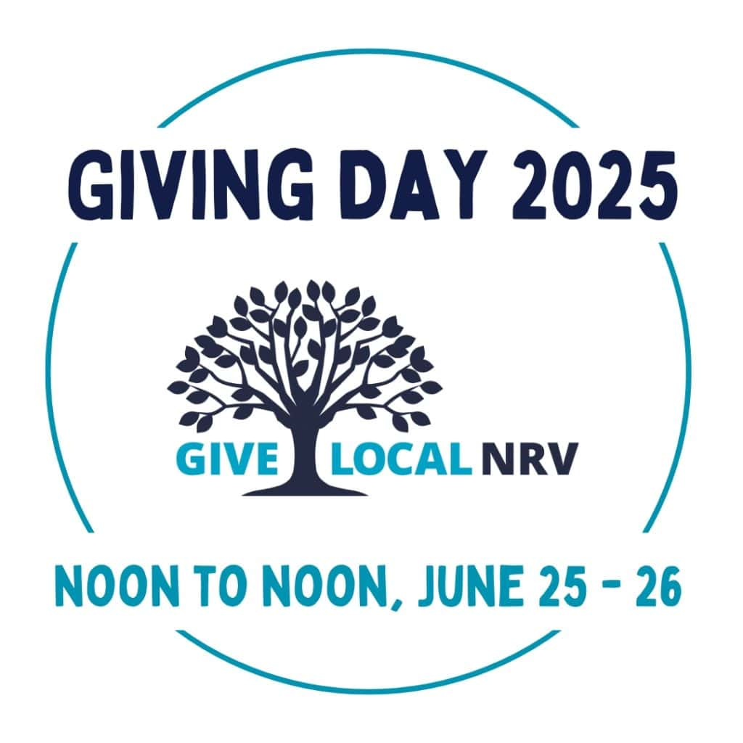

The 2025 Giving Day kicks off at noon on Wednesday, June 25th!

